L₂ Document
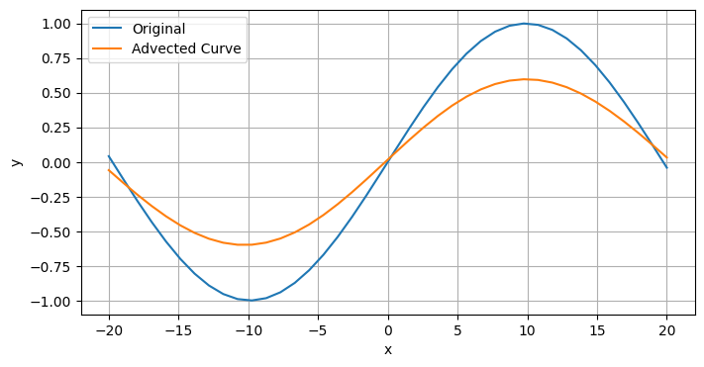
The L₂ error is: 0.3947
I then doubled the resolution in space and time
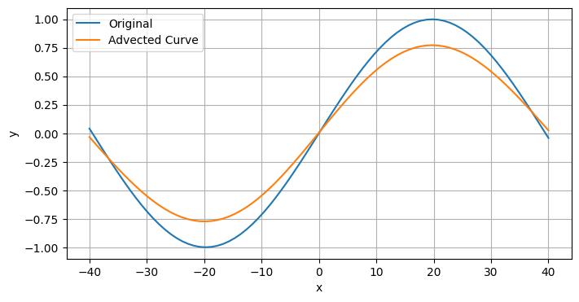
The L₂ error is 0.2221
I then doubled the resolution in space and time
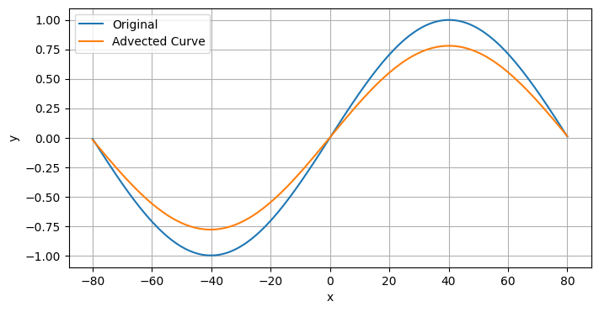
The L₂ error is 0.1161

